## Index data in Kendra

1. Search for Amazon Kendra in AWS Services

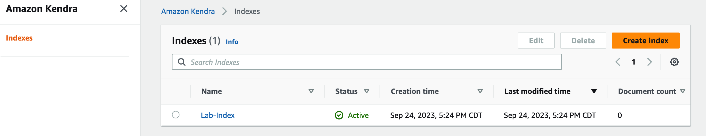

1. Click on “Lab-Index” and click on Data Sources

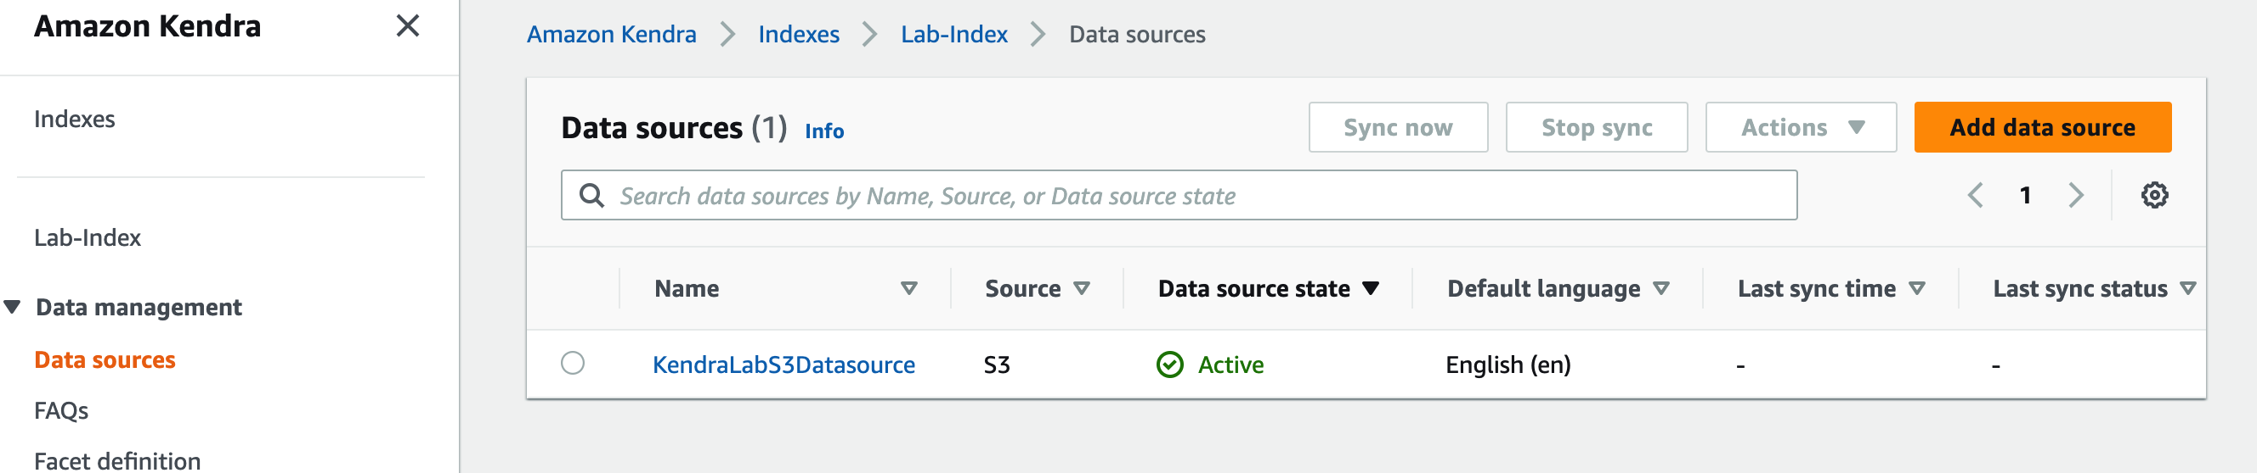

1. You will have a Data source already added to the Kendra Index. However, no data is indexed yet. Click on the “KendraLabS3Datasource” and select the “Settings” tab

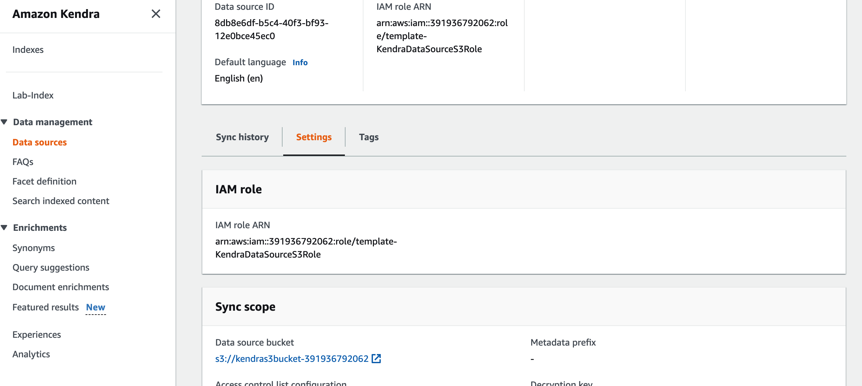

1. You should be able to find the Data Source Bucket. You will have to upload the data set on to this bucket. Click on the link to get to the bucket. Now upload the dataset on to bucket

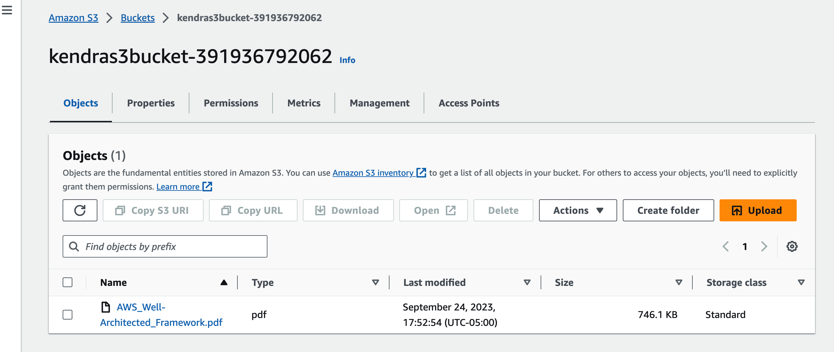

1. Now that data is uploaded, you can start the indexing in Kendra. Back in the Kendra Service, Click on “Sync Now”

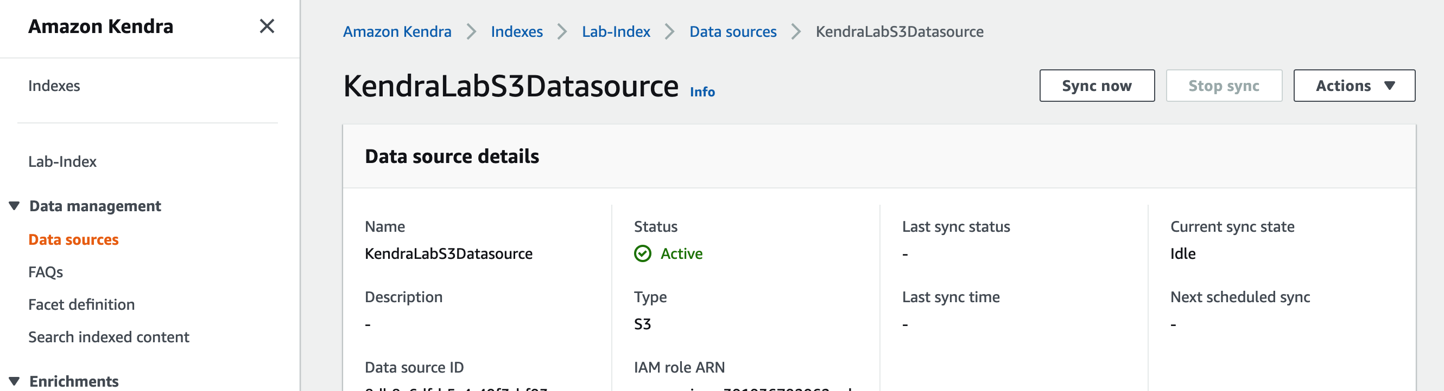

1. You will see the sync started



1. Once the Sync is complete. Check the number of documents indexed in Amazon Kendra

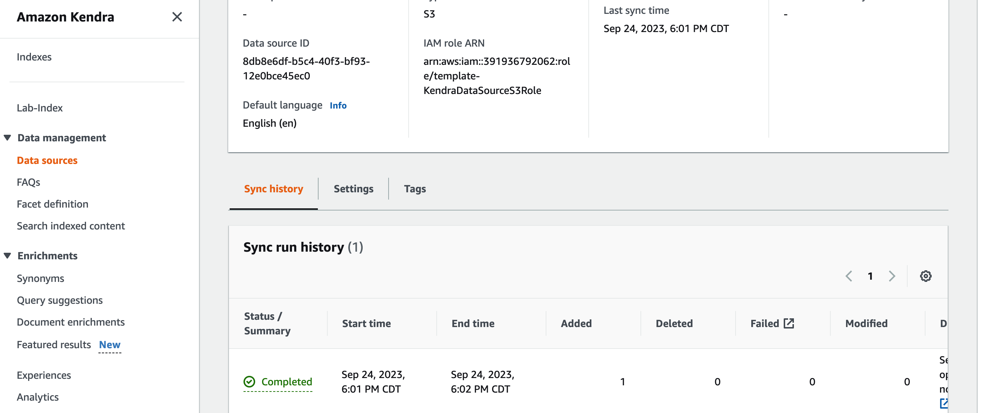

1. This completes the indexing on Kendra. Now you can test the Kendra search by clicking on “Search Indexed Content”

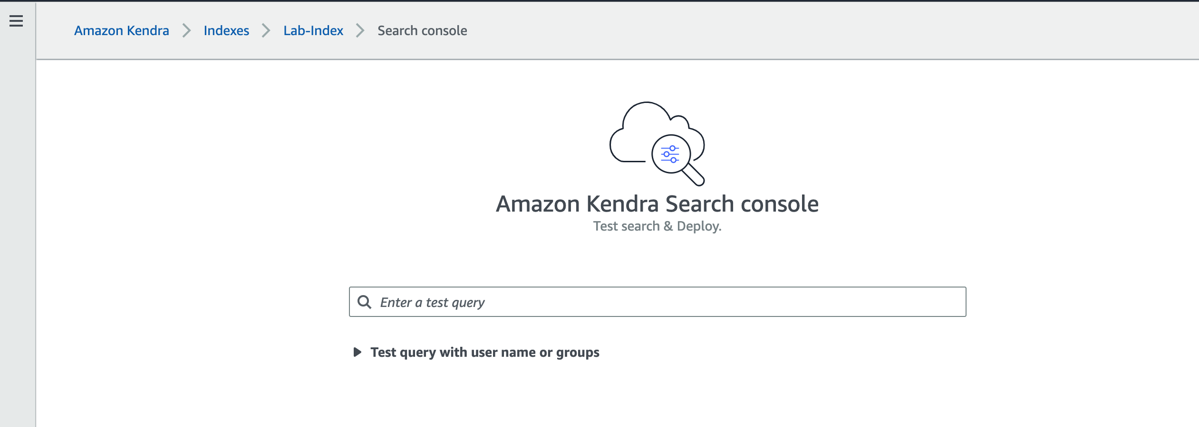

1. Type “5 pillars of well architected Framework”

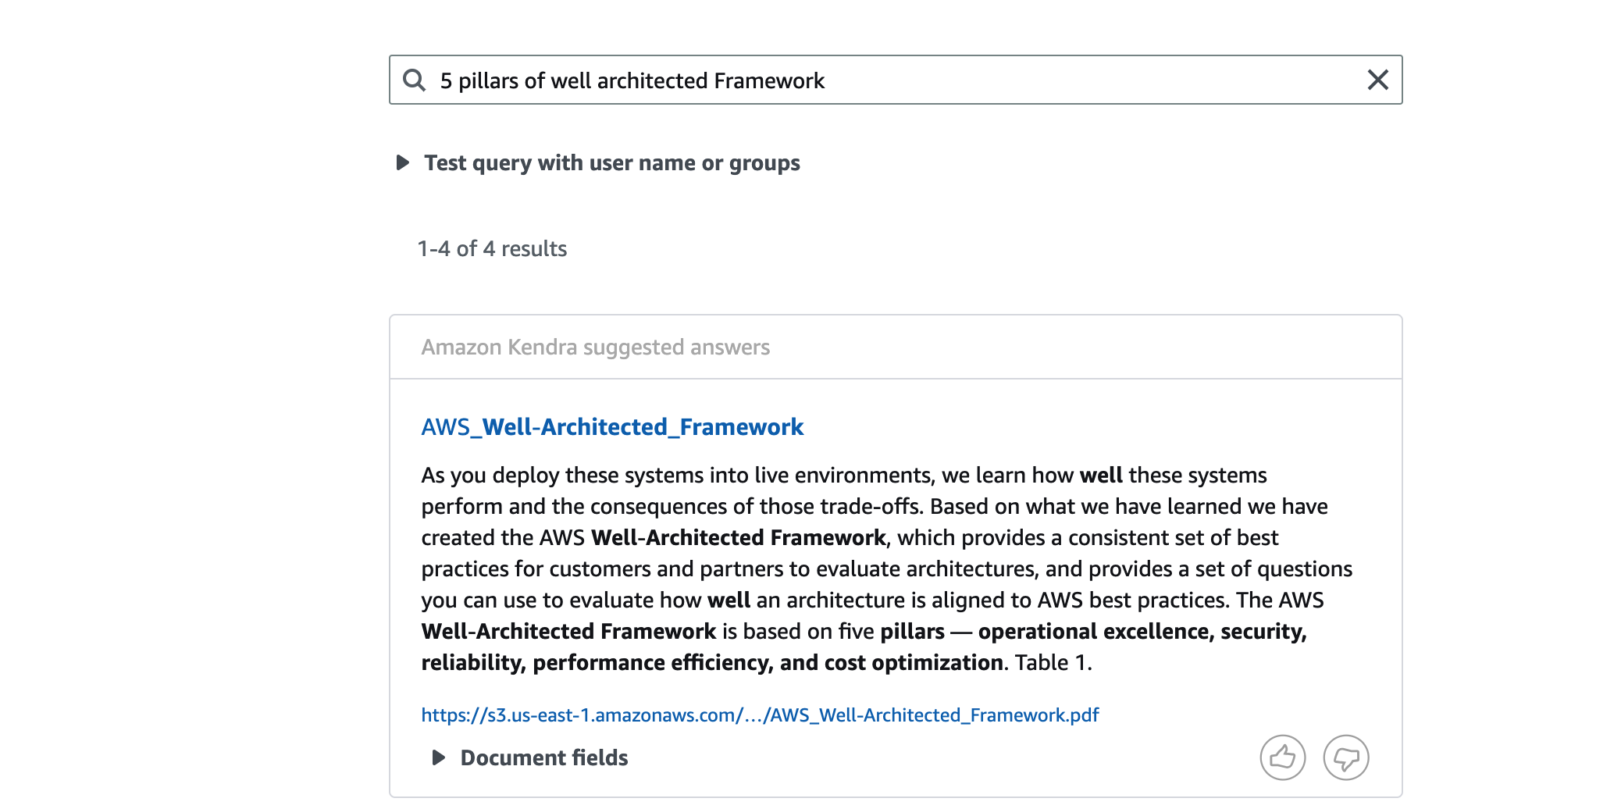

1. Now you can use the Kendra Index ID in your notebook “02-aws-qna-kendra-rag.ipynb”